Image | 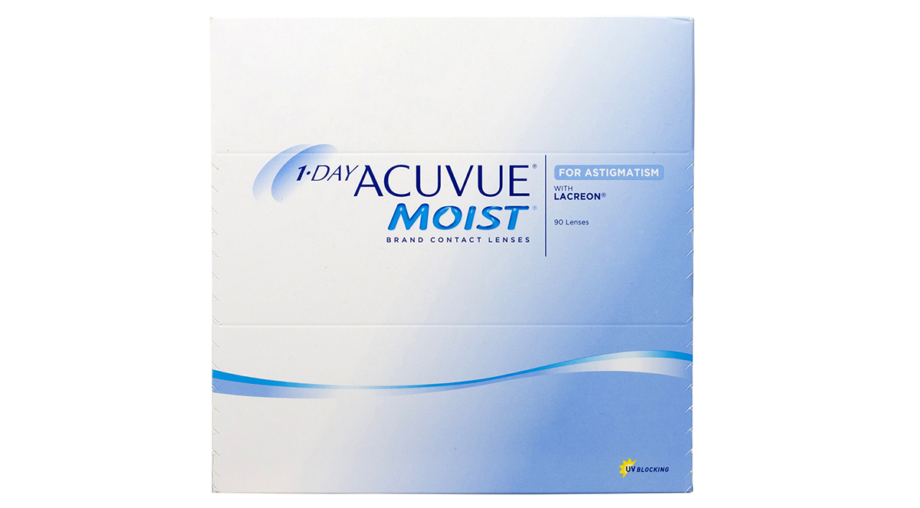
Brand | GUCCI
Model Name | acuvue-1-day-moist-for-astigmatism
Price | RS 2000
PRODUCT DETAILS

